Video Release Form
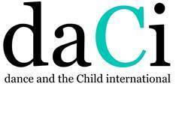
We need you to grant us permission to photograph and video record your participation in the Flash Mob Dance ‘One Billion Rising: Strike, Rise, Dance” and to post the video recording onto the daCi website on February 14th 2023.
By signing this agreement you give us the right to digitise and reproduce the photos and video footage taken before and during the Flash Mob Dance event “One Billion Rising: Strike, Dance, Rise” on the website for Dance and the Child International (daCi) for One Billion Rising
You also give permission to allow site visitors to the daCi website, accessible to daCi members only, to download and use the photos and video footage
By signing this agreement you are guaranteeing that you are the person who is participating in the Flash Mob Dance and being photographed and video-taped
The photos and video footage will remain on the daCi website as long as they are current or useful to our audience
We may modify or upgrade the website and remove or delete any images or footage that pertains to you without your consent and without recourse to you
Agreement
Agreement made on (date)__________________________________
Between (your name)______________________________________
And Dance and the Child International
Signed (your name)_____________________________________(or parents/guardians)
Send to: Adrienne Sansom (personalise as appropriate)
Email: a.sansom@auckland.ac.nz (personalise as appropriate)

